**Nilkamal Thakuria, 2018B5A70924P Assignment-I**

Q1 a) Generating random numbers (*Filename: Q1a.m*)



**Histogram**:  
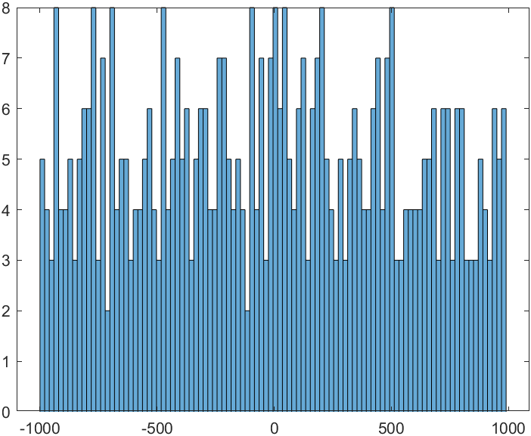

Console:



Q1 b and c) (*Filename: Q1_b_c.m*)

Sorting algo used: Bubblesort



**Outputs of 1c)**



**Q2 a)** Eigen-Values (Filename: Q2_EnergyEigenValues.m)





**Q2b) (Filename: Q2_air_resistance.m)**

Newton Raphson Method used to calculate t(time), by writing s(displacement) as a function of t, and finding its second roots, the first root being t=0.



Outputs

**Q3. File used: *Q3.m***

**Finding point of intersection of a given torus, sphere and plane using Newton Raphson Method**

  
  
OUTPUT:



Q4) **Legendre Polynomial curve fitting on an arbitrary interval [a,b]**

Files used**: *LegendrePolyCurveFitting.m****(answer to 4a)*, which contains the function, and ***Q4driverprogram.m*** is used to execute the function with the parameters(dataset, range, no of points to be generated).   


A dataset of 8 points was generated through the function f in the range [a=-5,b=5] and noise having 10% bar was added to it. All these parameters can be manipulated as per will in *Q4driverprogram.m*

f=@(x) 37*x^5+4*x.^4+0.5*x.^3+7*x;

noise=(randi(20,1,n)-10).*f(x)/100;

y=f(x)+noise;

The plot is built into the function itself (***LegendrePolyCurveFitting.m***). Green represents Legendre Polynomial Curve Fitting.

Q5c) File used: *Q5c_QuadraticSpline.m*

Outputs (Left graph represents quadratic spline, right cubic-spline. The green lines show the actual value of the function at corresponding x points)

1. f(x)=sin(x)

1. f(x)=tan(x)

1. f(x)=x^5+4*x^4+3*x+2;

1. f(x)=log(x)

